MATHEMATICS SPECIALIST

MAWA Semester 1 (Unit 3) Examination 2017

Calculator-assumed

Marking Key

© MAWA, 2017
Licence Agreement
This examination is Copyright but may be freely used within the school that purchases this licence.
- The items that are contained in this examination are to be used solely in the school for which they are purchased.
- They are not to be shared in any manner with a school which has not purchased their own licence.
- The items and the solutions/marking keys are to be kept confidentially and not copied or made available to anyone who is not a teacher at the school. Teachers may give feedback to students in the form of showing them how the work is marked but students are not to retain a copy of the paper or marking guide until the agreed release date stipulated in the purchasing agreement/licence.

The release date for this exam and marking scheme is
- the end of week 8 of term 2, 2017

Section Two: Calculator-assumed (92 Marks)

Question 8(a)
Solution
$$r=\vec{OP}+t\vec{PQ}=2i-3j+5k+t(3i+4j-8k)$$
Marking key/mathematical behaviours | Marks
- uses$r=\vec{OP}+t\vec{PQ}$ (or $r=\vec{OQ}+t\vec{QP}$)  - evaluates $\vec{PQ}$correctly  - writes vector eqn of line | 1  1  1

Question 8(b)
Solution
$x=2+3t,$ $y=-3+4t$ and $z=5-8t$
Marking key/mathematical behaviours | Marks
- chose correct format for parametric equations  - correct parametric equations | 1  1

Question 8(c)
Solution
$R$ lies on $l⟹$ $8=2+3t,$ $5=-3+4t$ and $0=5-8t$ for some $t$
From equation 1, $t=2$. But $t=2$ is not a solution of equation 3.
So $R$ does not lie on $l$
Marking key/mathematical behaviours | Marks
- obtains $8=2+3t,$ $5=-3+4t$ and $0=5-8t$  - shows that there is no simultaneous solution for $t$  - obtains the correct answer | 1  1  1

Question 9(a)
Solution
B
Q
C
R
S
D
A
P

So the opposite sides PQ and SR in the quadrilateral PQRS are parallel (and equal in length)
By a similar argument, the sides QR and PS are parallel.
Since both pairs of opposite sides are parallel, PQRS is a quadrilateral
Marking key/mathematical behaviours | Marks
- uses $\vec{PQ}=\vec{PB}+\vec{BQ}$  - uses mid-point property to establish  - shows that PQ and SR are parallel  - deduces that QR and PS are parallel  - states that quad is a parallelogram | 1  1  1  1  1

Question 9(b)
Solution
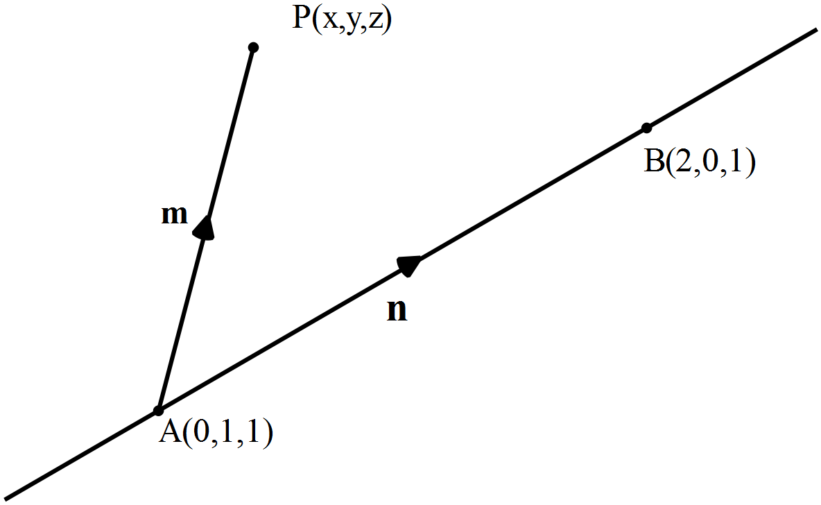

and
Marking key/mathematical behaviours | Marks
- draws a diagram to illustrate the situation  - evaluates  - determines in terms of  - shows how each of the components of the cross product are calculated  - calculates each correctly | 1  1  1  1  1

Question 10(a)
Solution
has roots at
So the possible roots of are 6,
For,
So all the possible real roots of are or
Or using a CAS calculator
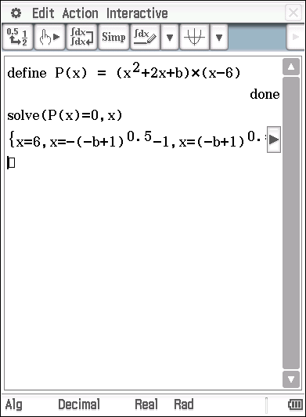
Substituting
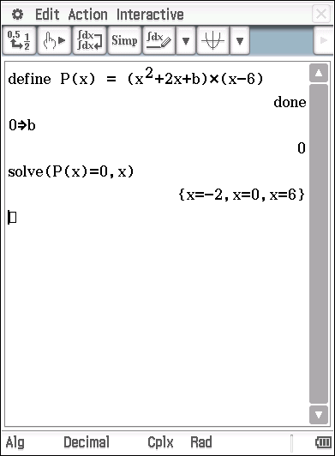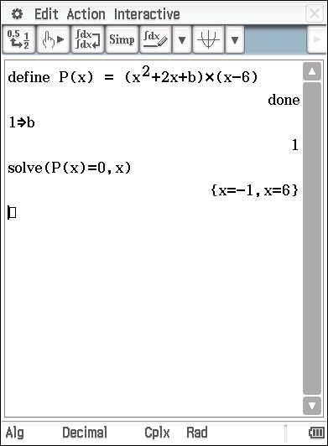
Marking key/mathematical behaviours | Marks
- Substitutes into and indicates is a root  - Applies the quadratic formula to determine the roots of  Or states them by use of a graphic calculator  - Indicates that  - Determines the set of roots for  - Determines the set of roots for b=1 | 1  1  1  1  1

Question 10(b)
Solution
Given
For ,
Here - so both rational
For , so is not rational. Similarly, for .
For , and so
Here - so again, both rational
Hence, for
And for
Or using a CAS calculator
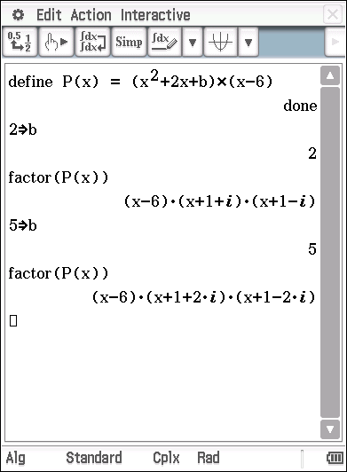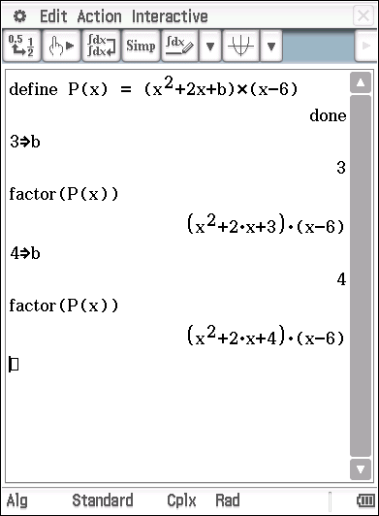

Marking key/mathematical behaviours | Marks
- Determines the complex linear factors of for or in the required form  - shows that are rational (by finding them)  - Repeats procedure for the other value of  - Shows that is irrational for and for  - States the three linear, rational factors of for and | 1  1  1  1  1

Question 11(a)
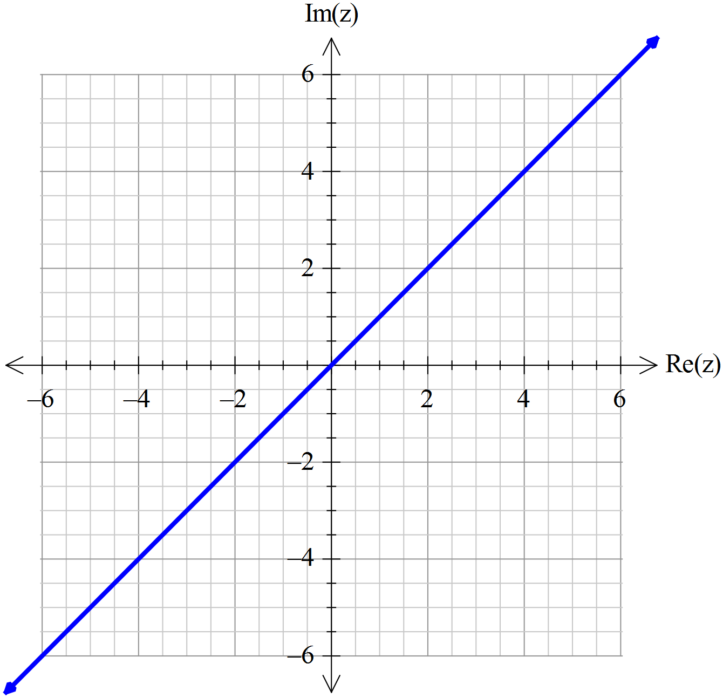Solution
Let

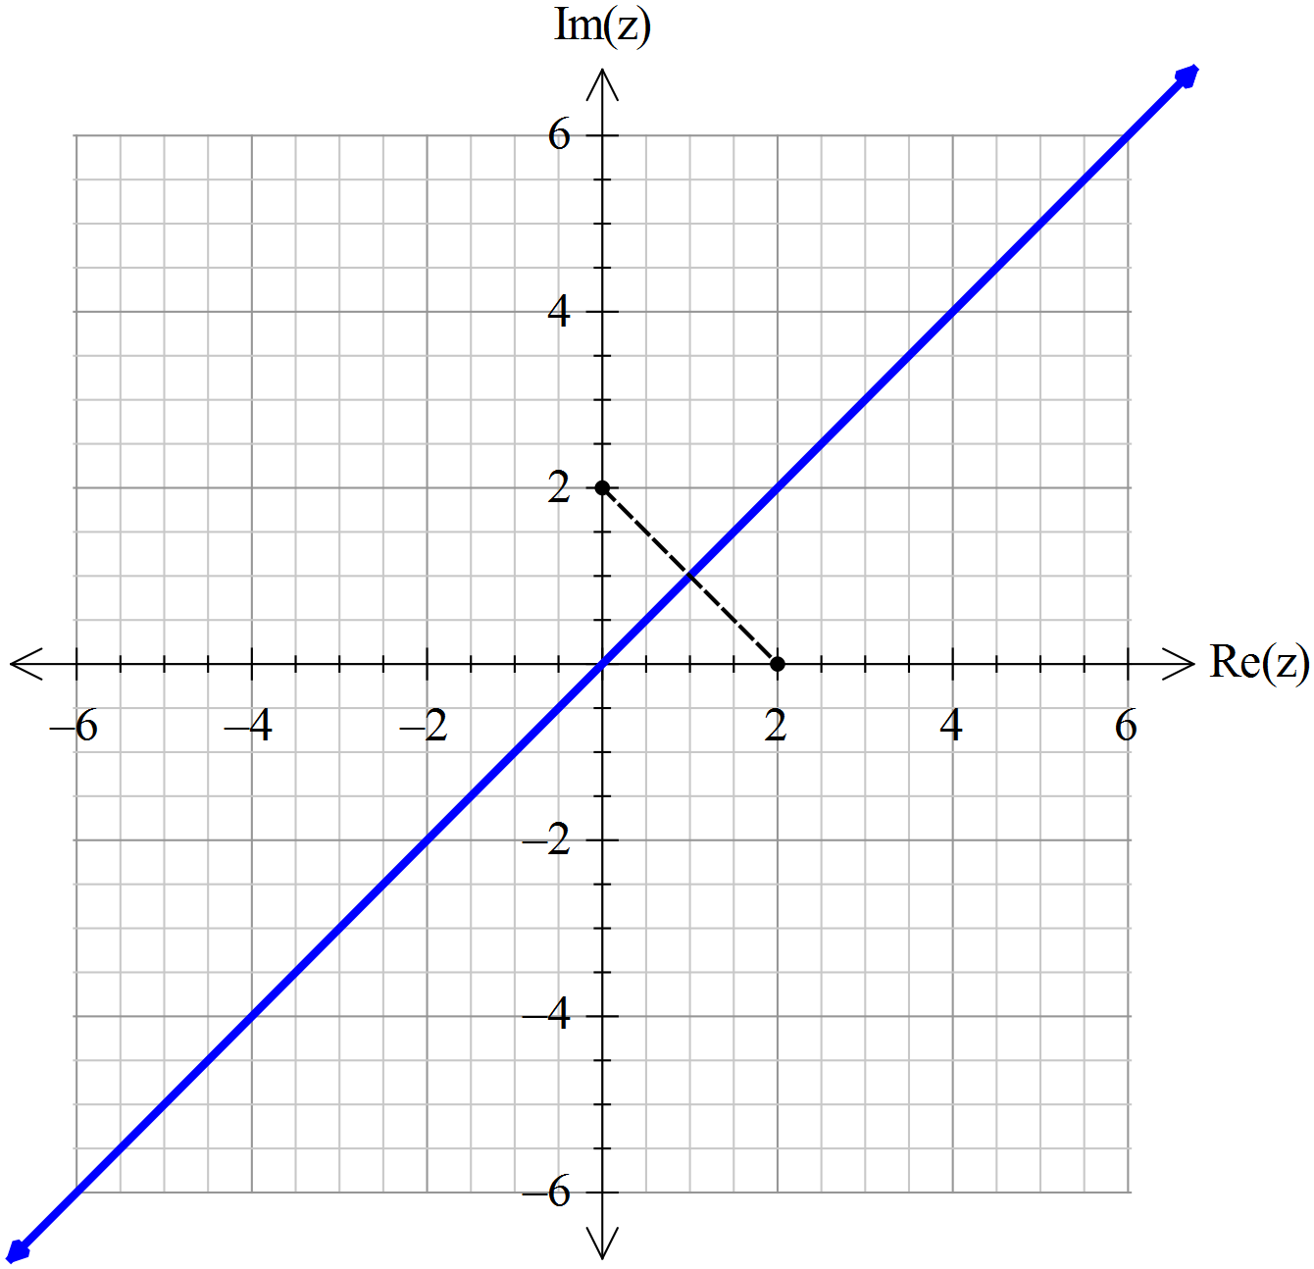Alternatively,

Note that the required solution set is the perpendicular
bisector of the line segment joining the points
Plot
Draw the perpendicular bisector

Marking key/mathematical behaviours | Marks
- Calculates the magnitude of each part and equates  - Determines  - Graphs the line  Alternatively,  - Plots the points  - Indicates that the perpendicular bisector of the line segment joining these points is the solutions set required  - Draws the bisector accurately | 1  1  1  1  1  1

Question 11(b)
Solution
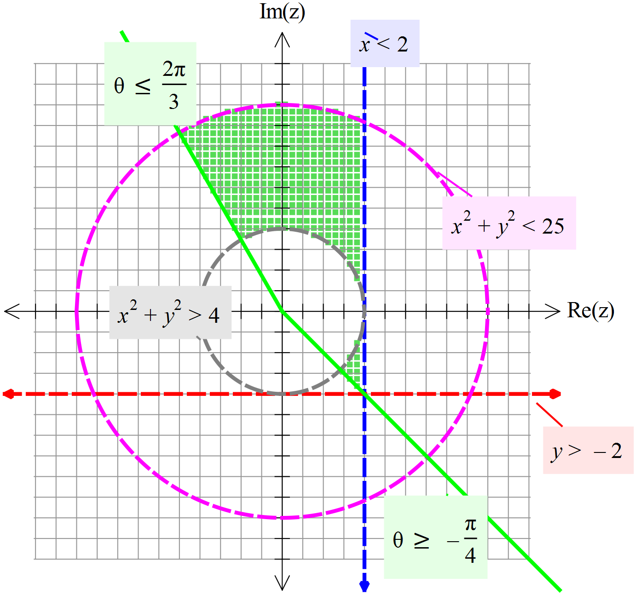

Draw each of the given inequalities

indicate which are dotted lines and
which include the points of the line
or circle.

Shade the regions that meet all the
conditions.

Marking key/mathematical behaviours | Marks
- Each inequality graphed correctly (without the shading)  - Correct regions that meets the conditions  - Correct boundaries for these regions | 6  1  1

Question 12
Solution
, and
So the 5th roots of are:

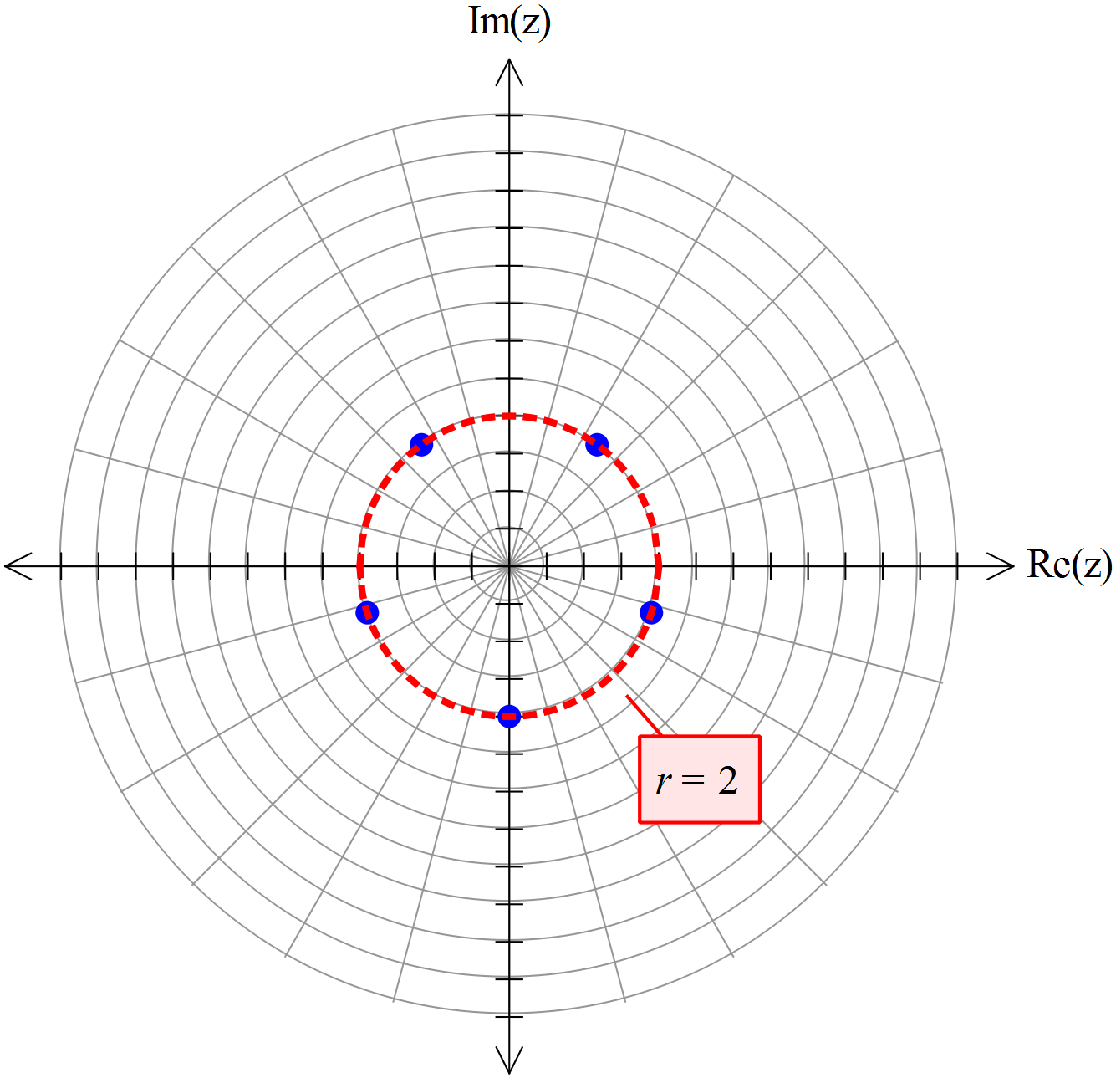

Marking key/mathematical behaviours | Marks
- converts in polar form correctly  - Determines and  - Determines the other four values of  - Represents the five values of on the Argand plane  - Accurately places the roots on a circle with a scale indicating the radius | 1  1  1  1  1

Question 13
Solution
Let
So

Marking key/mathematical behaviours | Marks
- Substitutes into given equation  - Substitutes into given equation  - Compares real and imaginary parts  - Determines  - Determines the two values for  - States values of | 1  1  1  1  1  1

Question 14(a)
Solution
$\vec{AB}=3i+4j$ and $\vec{AC}=3i+k$ lie in $P$
so $n=\vec{AB}×\vec{AC}=\left(3i+4j\right)×\left(3i+k\right)=4i-3j-12k$ is normal to $P$
Marking key/mathematical behaviours | Marks
- obtains 2 non-parallel vectors in $P$  - calculates the cross product correctly | 1  1

Question 14(b)
Solution
Vector equation $r∙n=c$ for $P$is $4x-3y-12z=4×-3=-12$
Marking key/mathematical behaviours | Marks
- obtains a vector equation  - obtains a Cartesian equation | 1  1

Question 14(c)
Solution
At the point of intersection
$4\left(3-3t\right)-3\left(5+2t\right)-12t=-12$
i.e. $-3-30t=-12,$ i.e. $t=0.3$
So the point of intersection has coordinates $\left(3-0.9,5+0.6,0.3\right)=\left(2.1,5.6,0.3\right)$
Marking key/mathematical behaviours | Marks
- substitutes for $r$ in vector equation of $P$  - solves for $t$ correctly  - states correct coordinates | 1  1  1

Question 15(a)
Solution
$x=3\cos{kt}$and $y=-2\sin{kt,}$
so ${\left(\frac{x}{3}\right)}^{2}+{\left(\frac{y}{-2}\right)}^{2}=\cos^{2}{kt+\sin^{2}{kt=1}}$ i.e. $\frac{x^{2}}{9}+\frac{y^{2}}{4}=1$
Marking key/mathematical behaviours | Marks
- obtains the formulae for $x$ and $y$  - uses trig identity  - eliminates $t$ correctly | 1  1  1

Question 15(b)
Solution
The path is an ellipse.
Marking key/mathematical behaviours | Marks
- obtains correct answer | 1

Question 15(c)
Solution
$v\left(t\right)=-3k\sin{kt i-2k\cos{kt}} j,$ and
$a\left(t\right)=-3k^{2}\cos{kt}{i+2k^{2}\sin{kt}} j,$
Marking key/mathematical behaviours | Marks
- correct answer for $v(t)$  - correct answer for $a(t)$ | 1  1

Question 15(d)
Solution
$r\left(0\right)=3 i$ and $v\left(0\right)=-2k j$
So at (3,0), the extreme ‘easterly’ end of the path, the train is moving ‘south’, i.e. in the ‘negative’ direction of the $y$ axis. So the train is moving in a clockwise direction around the closed path.
Marking key/mathematical behaviours | Marks
- obtains the correct answer  - gives a valid reason | 1  1

Question 15(e)
Solution
$v\left(t\right)∙a(t)=9k^{3}\sin{kt}\cos{kt-4k^{3}\sin{kt}\cos{kt}=5k^{3}\sin{kt}\cos{kt}}$
So $v\left(t\right)∙a(t)=0$ when $\sin{kt=0 }$ or $\cos{kt=0}$
$\sin{kt=0⟺(x,y)=(±3,0)}$ and $\cos{kt=0⟺\left(x,y\right)=(0,±2)}$
So the velocity and acceleration are mutually perpendicular at the points $\left(3,0\right), \left(-3,0\right), \left(0,2\right)\text{ and }\left(0,-2\right).$
Marking key/mathematical behaviours | Marks
- uses $v\left(t\right)∙a(t)=0⟺\text{perpendicularity}$  - obtains $v\left(t\right)∙a(t)$correctly  - obtains correct answers | 1  1  1

Question 15(f)
Solution
$92k=2π$ so $k=0.0683,$ correct to 3 significant figures
Marking key/mathematical behaviours | Marks
- uses $92k=2π$  - obtains solution, correct to 3 sig. figs. | 1  1

Question 15(g)
Solution
$v\left(t\right)=-0.205\sin{0.0683t i-0.137\cos{0.0683t}} j,$ (from (c) and (f))
so ${v\left(t\right)}^{2}={(-0.205)}^{2}\sin^{2}{0.0683t}{+{(-0.137)}^{2}\cos^{2}{0.0683t}}$
$$={(-0.205)}^{2}-0.0233\cos^{2}{0.0683t}$$
So $v_{max}=0.205$ i.e. the maximum speed is 20.5 centimetres per second
Marking key/mathematical behaviours | Marks
- obtains correct expression for $v\left(t\right)$  - recognizes speed as the length of the velocity vector  - obtains the correct answer | 1  1  1

Question 16(a)
Solution
$$x^{2}-6x+y^{2}+z^{2}+10z=2⟺{\left(x-3\right)}^{2}+y^{2}+{\left(z+5\right)}^{2}=2+9+25=36=6^{2}$$
So the radius is 6 and the centre $C$ has coordinates $(3,0,-5)$
Marking key/mathematical behaviours | Marks
- completes the square  - obtains correct radius  - obtains correct coordinates of $C$ | 1  1  1

Question 16(b)
Solution
Substituting $\left(x,y,z\right)=(9+2t,-2t,1+t)$ in the equation of the sphere gives
$${(9+2t)}^{2}-6\left(9+2t\right)+{\left(-2t\right)}^{2}+{\left(1+t\right)}^{2}+10\left(1+t\right)=2,$$
i.e. $38+36t+9t^{2}=2,$ i.e. $9{(t+2)}^{2}=0,$ i.e. $t=-2$ (or by calculator)
so $l$ and $S$ intersect
so $\left(x,y,z\right)=(5,4,-1)$ at the only point of intersection
Marking key/mathematical behaviours | Marks
- substitutes correctly  - sets up an equation for t  - solves for $t$  - deduces that the line and sphere intersect  - solves for the coordinates $x,y$ and $z$ at the only point of intersection | 1  1  1  1  1

Question 16(c)
Solution
If $P$ is the point of intersection $CP=2i+4j+4k$,
The vector $2i-2j+k$ is parallel to the line $l$,
And $\left(2i+4j+4k)⋅(2i-2j+k\right)=4-8+4=0$
So the direction of the line is perpendicular to the radial vector $CP.$
Since $P$ is the point of intersection of $l$ and $S$, $l$ must be tangential to $S$ at $P.$
Marking key/mathematical behaviours | Marks
- shows that $l$ is perpendicular to the radial vector at the point of intersection  - argues that this implies the tangency property for $l$ | 1  1

Question 17(a)
Solution
The midpoint of -8 and 2 on the real number line is -3.
Marking key/mathematical behaviours | Marks
- uses points -8,2  - obtains correct answer | 1  1

Question 17(b)
Solution
Hence,
Marking key/mathematical behaviours | Marks
- uses endpoints of inequality  - solves for  - chooses correct value for | 1  1  1

Question 17(c)
Solution
Graphs overlap on the interval .
The graph of has been translated horizontally 2 units in the positive direction, reflected in the horizontal axis and then translated vertically 4 units in the positive direction.
Hence and .

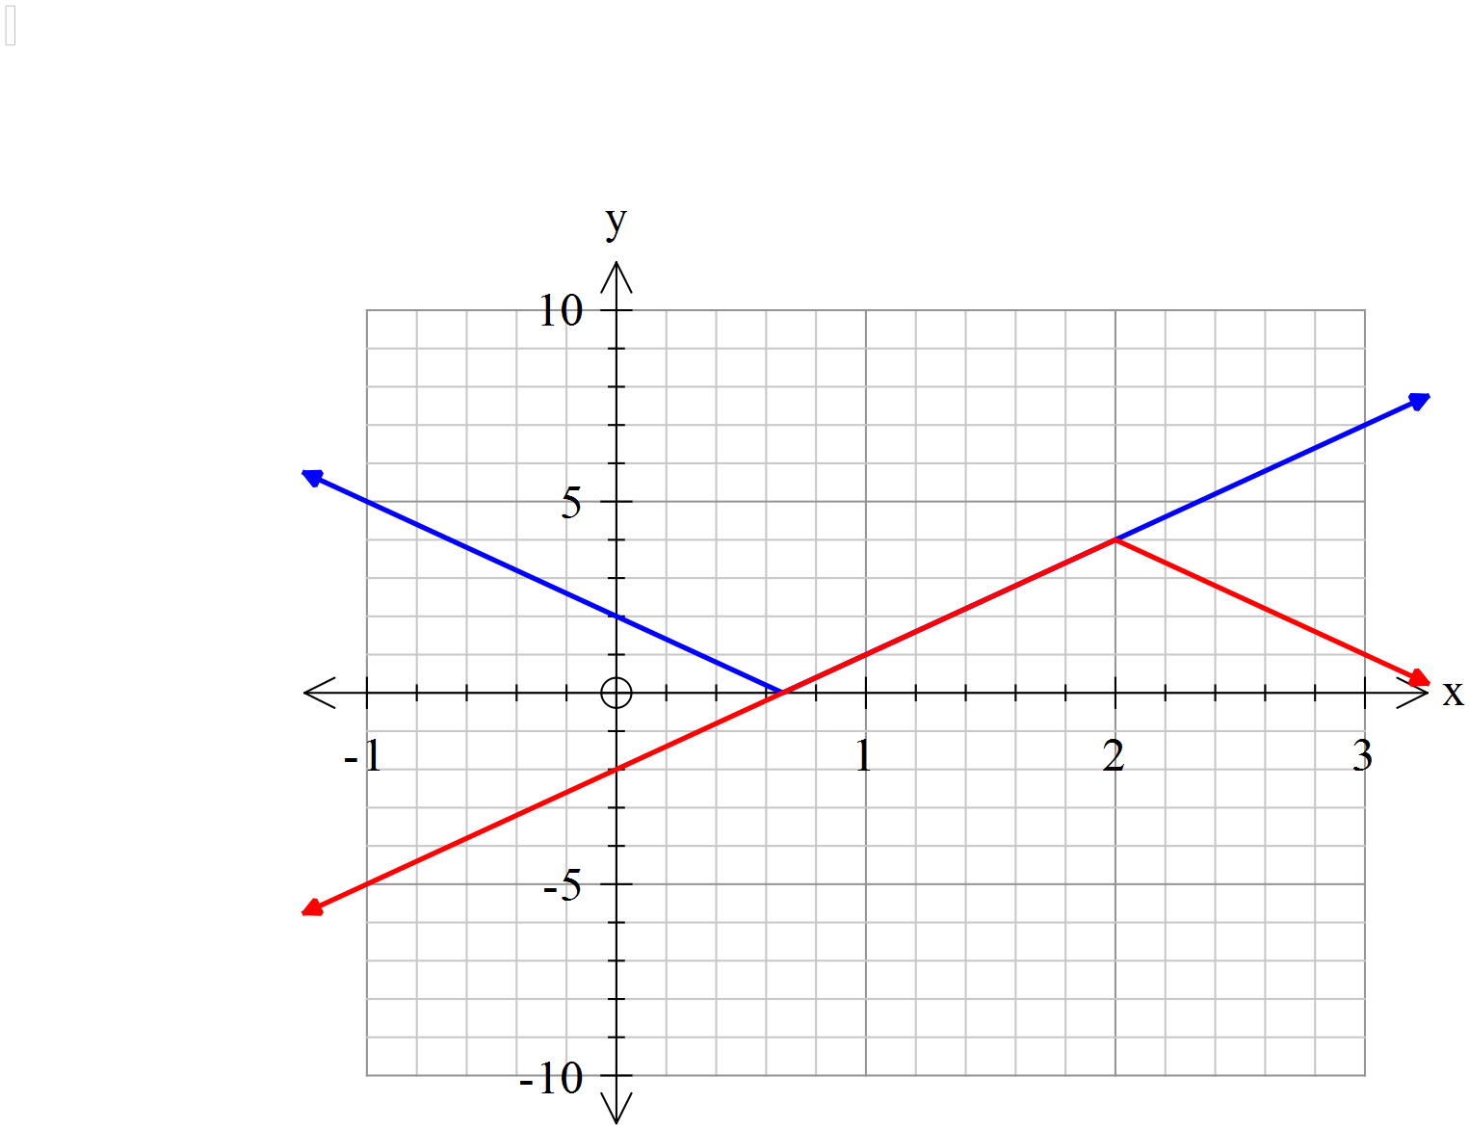
Marking key/mathematical behaviours | Marks
- recognizes that graphs overlap on given interval only  - obtains -3 for p  - obtains q=-2  - obtains s=4 | 1  1  1  1

